Oberlin High School
Family and Consumer Management
Grade 7
Date: March 15-26, 2021
Basic Surface Design -NOTES

Definition of terms
Surface design is any type of artwork (pattern, illustration, hand lettering, etc.) made by a designer that is intended to be applied to a surface to enhance its visual appearance and/or functionality.
Embellishments - a decorative detail or feature added to something to make it more attractive.

What are some types of basic surface design?
- Embroidery
- Appliqué
- Painting
- Printing
- Beading
- Tie and Dye

- Embroidery - Embroidery is the craft of decorating fabric or other materials using a needle to apply thread or yarn.
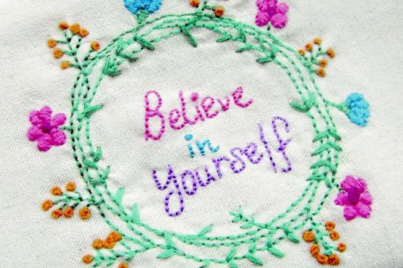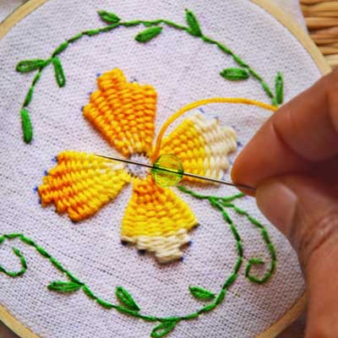
- Applique - a decoration that is sewn onto a larger piece of fabric. One material is being attached to another. Start with a base such as a blanket, a shirt, a potholder, or practically any other human-made fabric. Appliqué generally implies the attaching of one textile to another one, but beads, sequins, and similar decorative elements can easily be incorporated into the design.
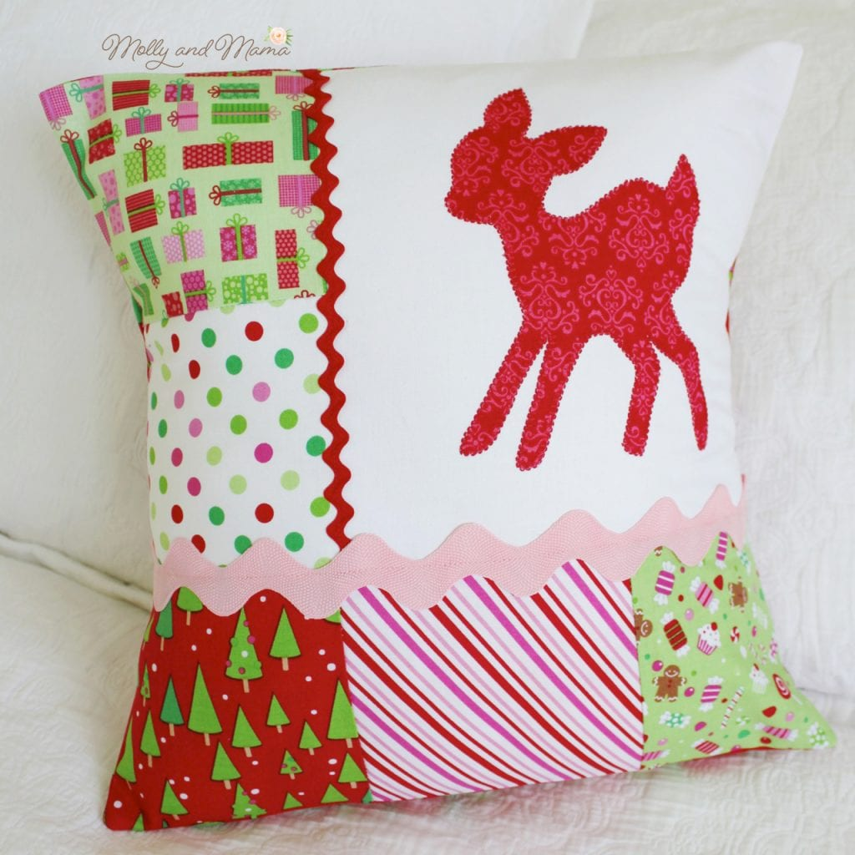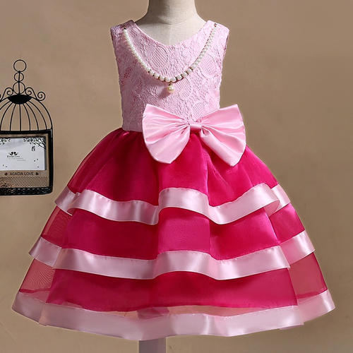
- Painting techniques are ways of creating colourful pictures and designs on fabric using paints and brushes, markers or stencils.
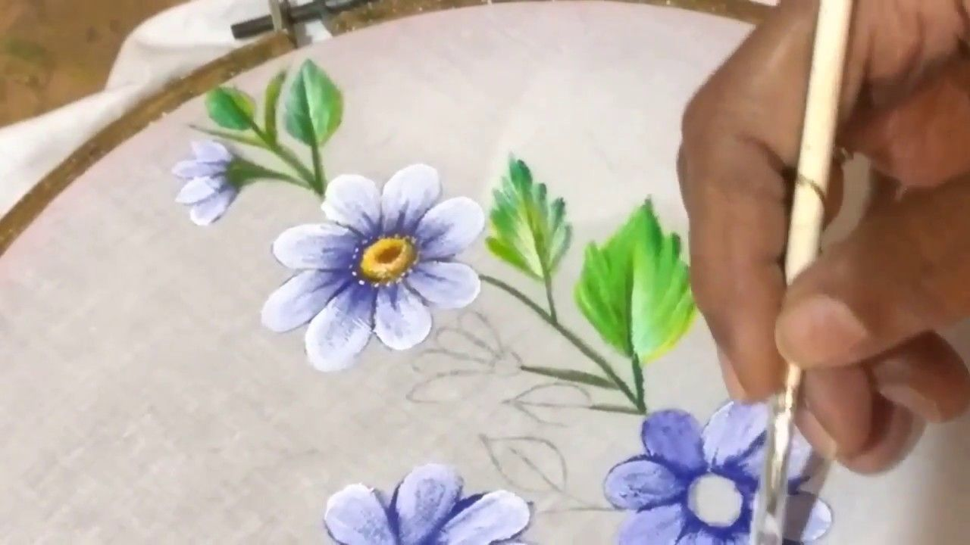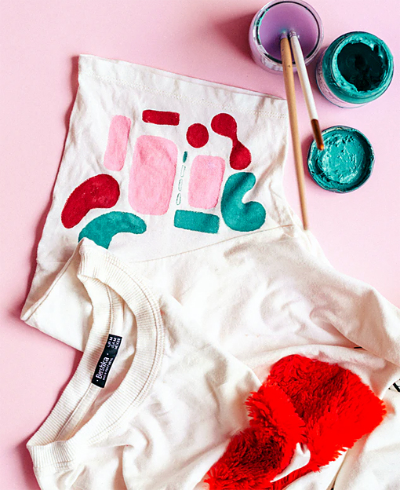

Beading: is the art or craft of attaching beads to one another by stringing them with a sewing needle or beading needle and thread or thin wire, or sewing them to cloth. Beads come in a variety of materials, shapes and sizes. Beads are used to create jewellery or other articles of personal adornment.
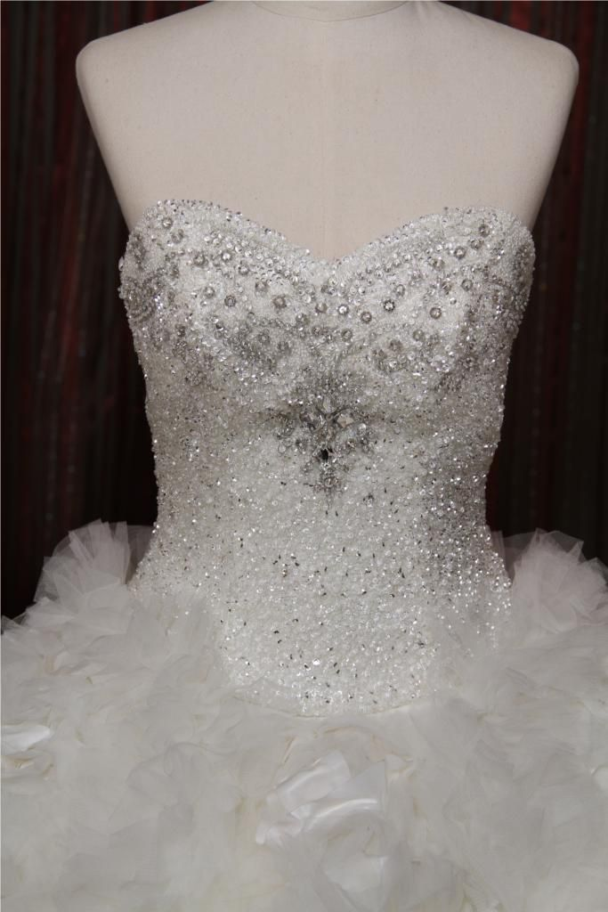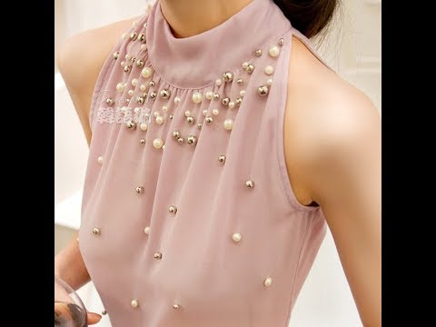

- Tie and Dye - a resist method that keeps dye from getting into certain areas in order to create a pattern. Dyes used may be natural such as those obtained from plant, animal and mineral sources, or may be synthetic.
Examples of natural dyes are:
Indigo, henna and saffron from vegetables and tyrian purple, squid sepia from fish and small insects. Coal is used in manufactured synthetic dyes.
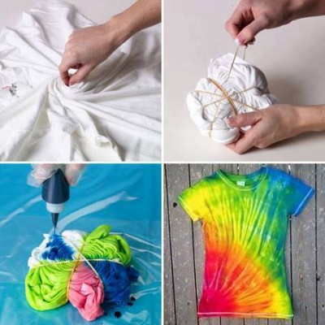
Printing
Printing makes use of colour to decorate fabrics. A pattern is decided on and a suitable method is chosen to apply the colours to the fabric. Fabric may be printed by hand, rollers, screens and stencils eg. https://www.youtube.com/watch?v=eucQNEMCY5A



