Oberlin High School
Subject: Family and Consumer Management
Grade: 8
Date: March 1-12, 2021
Topic: Method of Cooking
Methods of Cooking- Notes
What is cooking?
Cooking is the preparation of food for eating by applying heat.
Reasons for Cooking Food
- to kill harmful bacteria.
- to soften them and make them easier to digest
- to make food more appetizing.
- to bring out full flavour.
- to give variety

Factors to consider when selecting cooking Method
- the type of food to be cooked.
- amount of time and money available.
- the quantity of food to be cooked.
- the facilities and fuel available.

Classification of Cooking Methods.
- Moist: Boiling, Steaming. Stewing, Poaching
- Dry: Baking, Roasting, Grilling or Broiling
- Frying
- Combination: Braising

Description of cooking methods- Frying and Steaming.
Frying: Frying is cooking in hot fat or oil until the outside is crisp or sealed and the inside cooked.

Types of frying are:
- Dry frying- no fat is used. The foods already contain their own fat, for example: bacon.
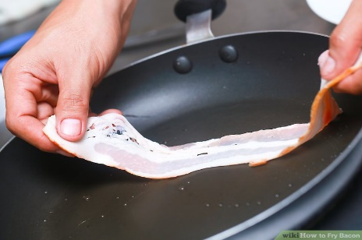
- Shallow frying- just enough fat is used to cover the bottom of the pan. For example: eggs, fish fillet, sausages, liver.
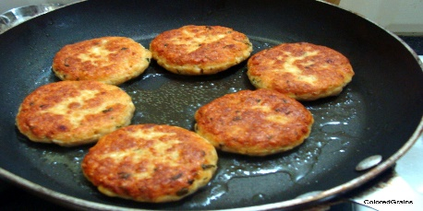
- Deep-fat frying- the food is completely covered by the fat for example: chicken, plantain chips, doughnuts, French fries, fritters.
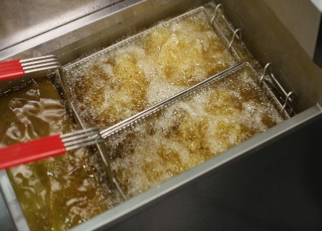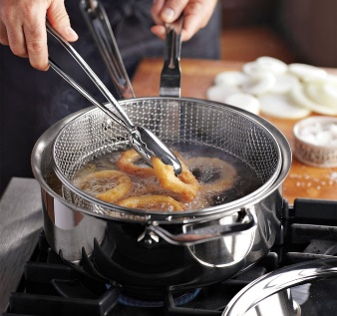

Suitable foods for frying are: chicken, plantain, fish, eggs, tender cuts of meat.

Advantages of Frying
- Quick and easy method.
- Very attractive.
- Suitable for small pieces of food.
- Little preparation is needed.
- Little loss of food value.

Disadvantages of Frying
- Needs constant and careful attention to prevent burning.
- Fat must always be at the correct temperature so that food does not get soggy.
- Not suitable for large, thick or tough pieces of food.
- Expensive- fat or oil must be of a good quality.
- Fried foods may be indigestible.

Preparation of food before Frying
Before frying, some foods have to be coated. They must be coated to:
- Prevent them from absorbing fat.
- Prevent them from sticking to the pan.
- Prevent food juices from escaping.
- Prevent them from breaking up
- Make them more attractive.

Types of coating for fried foods:
- Batters
- Eggs and breadcrumbs
- Milk and seasoned flour
- Seasoned flour
- Cornmeal

Rules for Frying
The fat or oil for frying must be the correct temperature before use. Successful rules for frying are:
- Use clean fat or oil
- Use a dry, strong pan
- Heat the fat to the correct temperature before use.
- Do not attempt to fry too many pieces at the same time. This lowers the temperature of the fat and causes the food to absorb the fat.
- Place food gently into the pan or use a frying basket to prevent splashing
- Avoid piercing food while turning. Piercing causes food juices to escape.
- Dry wet foods to remove excessive moisture before coating.
- Keep the heat low to prevent burning.
- Drain fried foods on absorbent paper.

Steaming
This is coking food in the steam that rises from boiling water.

Types of steaming:
- Between two plates over a pan of boiling water.
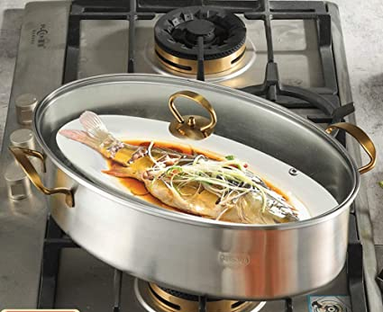

- In a double boiler.
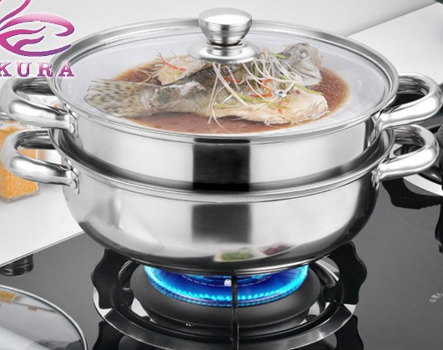
- In a covered vessel in a pan of boiling water.
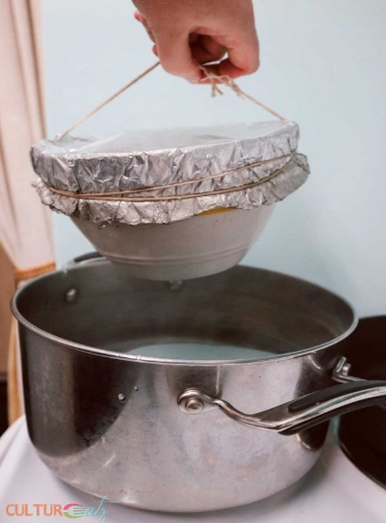

- In a perforated vessels over a pan of boiling water.
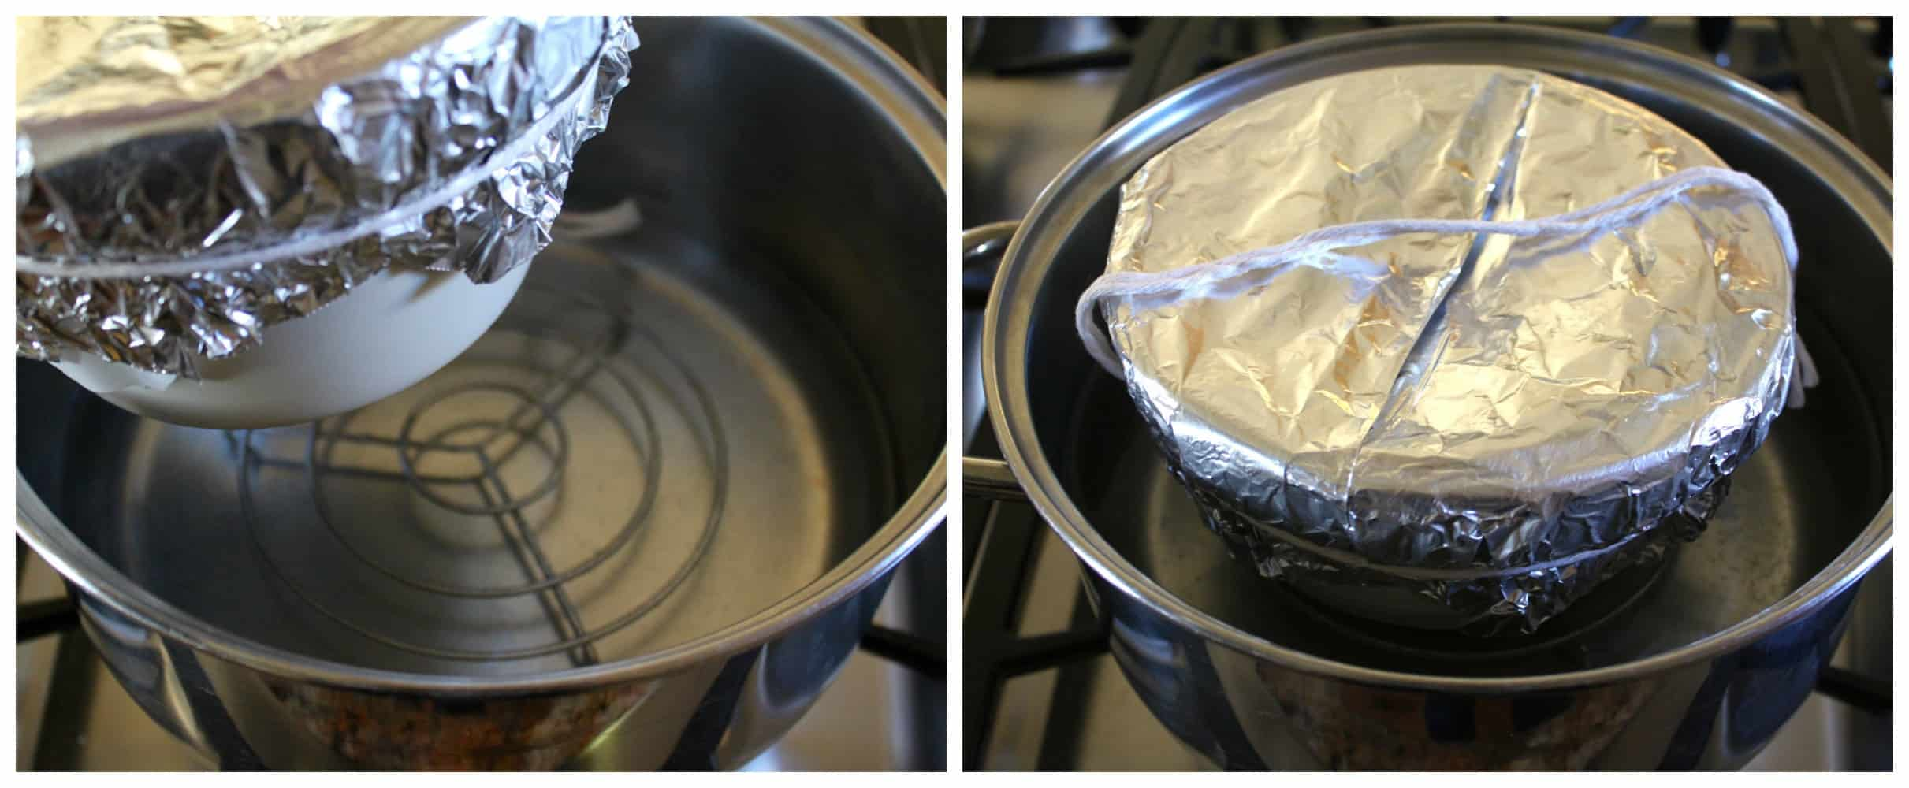

Suitable foods for steaming are: fish, chicken, green vegetables, root vegetables, tender cuts of meat, rice, puddings.

Advantages of steaming
- Food is easily digested, therefore ideal for chicken and convalescents.
- Cold food can be easily warmed through this way.
- Food is not overcooked.
- Economical: more than one food can be cooked at the same time.

Disadvantages of steaming
- Needs attention as water may need replenishing.
- In some cases, it is a slow method of cooking.

Rules for steaming
- Always keep a kettle of boiling water handy to replace water that has evaporated.
- Steamer must never boil dry.
- Food should never come in contact with water.
- Use aluminum foil or heavy waxed paper for covering puddings as they may become soggy from condensed steam.
- Cut pieces of food thinly so that steam can penetrate easily.

