OBERLIN HIGH SCHOOL
Integrated Science Grade 8
March 29th – April 2nd
The Digestive system
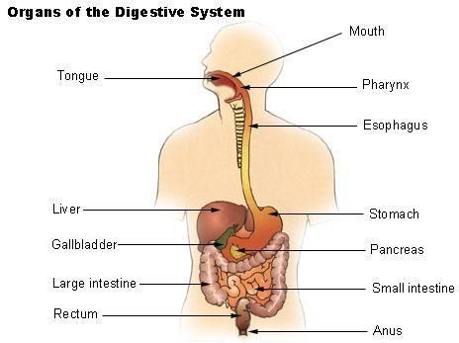
Structures of the digestive system | Function
Mouth/ Oral cavity | - Mastication. Mechanical/Physical digestion of food using teeth and tongue  - The salivary gland Secretes saliva which helps to soften the food. Saliva also contains salivary amylase, an enzyme that breaks down starch to maltose.  - Starch digestion begins in the mouth  - The tongue rolls the food into a bolus and the food is swallowed.
Oesophagus | - Narrow tube that carries food from the mouth to the stomach by peristalsis
Stomach | - Walls of stomach secretes gastric juice that contains hydrochloric acid and enzymes  - Walls of the stomach mixes food with gastric juice to produce chyme  - Protein digestion begins in the stomach
Liver | - Secretes bile that emulsify fats
Gall bladder | - Stores bile that is made by the liver and release it into the duodenum
Bile duct | - Carries bile to the duodenum
Pancreas | - Secretes pancreatic juice that contains enzymes (amylase, trypsin, lipase) and sodium bicarbonate
Small intestine (Duodenum) | - Secretes the enzymes sucrase, maltase, lactase, and peptidase  - Digestion is completed in the duodenum
Small intestine (ileum) | - The products of digestion are absorbed into the bloodstream
Large intestine (Colon) | - Absorption of water and salts back into the blood.
Rectum | - Stores faeces
Anus | - Pass faeces out of the body

The digestive process
The three main nutrients that are digested are carbohydrates, proteins and lipids. The digestion of each of these nutrients will begin in a different part of the digestive system and the completion of the digestive process will occur in another part of the digestive system.
Digestion in the mouth
- The digestive process begins in the mouth where starch is broken down by salivary amylase to form maltose
Salivary amylase + starch = maltose
- The food will then be rolled into a bolus and swallowed (move into the oesophagus)

Oesophagus

- The role of the oesophagus is to carry the food from the mouth to the stomach by the process known as peristalsis.
- No enzyme is found in the oesophagus hence no digestion can take place in this structure.
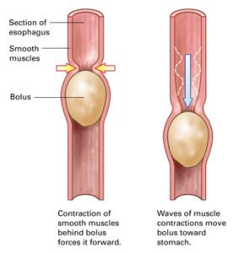

Diagram of a bolus travelling along the oesophagus by peristalsis

Digestion in the stomach
- The stomach produces gastric juice. Gastric juice consists of the enzyme pepsin and rennin along with hydrochloric acid.
- The stomach will churn (mix) the food with the gastric juices forming a mixture known as chyme.
- The hydrochloric acid kills any microbe (bacteria) that may have entered along with the food and to provide the correct pH for the enzymes to work.
- The digestion of proteins will begin with pepsin breaking down proteins to form polypeptides.

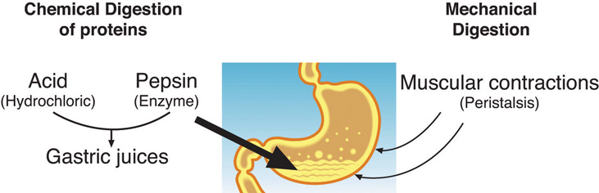

Note: Rennin is found mostly in the stomach of babies and infants, where it is needed in the digestion of milk.

Important: The digestion of starch ceases in the stomach because amylase is denatured by the hydrochloric acid.

Class Activity
    - Can the enzyme salivary amylase work in the stomach?
1b. In question one above, if the answer is yes or no, explain why?
2 What do you think would happen if there are no enzymes in the digestive system?

