OBERLIN HIGH SCHOOL
MATHEMATICS DEPARTMENT
GRADE 10
IDENTIFYING PARTS OF QUADRATIC GRAPHS (PART 3)
Example:
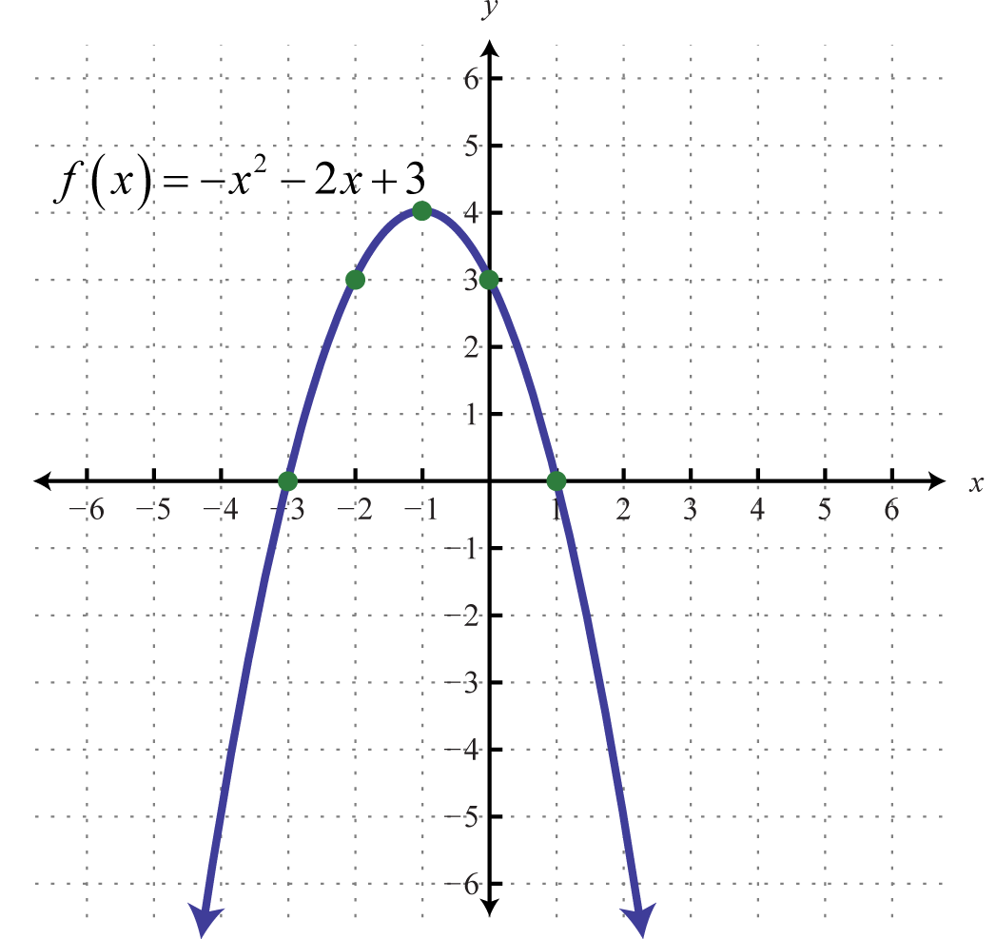
From the graph above state:
- The x-intercepts – (-3, 0) , (1, 0)
- The y-intercept – (0, 3)
- The vertex – (-1,4)
- The equation of the axis of symmetry – x = -1
- The maximum value of the function.- y = 4
- The coordinates of the maximum value – (-1,4)
- The values for x for which x² - 2x + 3 = 0 – x=-3 or x = 1
- The value of f(x) when x = 0 – y =3
- The values of x when f(x) = -5 – x =-4 or x=2
- The interval within which x lies when f(x)>3. Write your answer in the form a< x < b - -2< x < 0

ACTIVITY

Name_________________________________________________

Date __________ Class ________

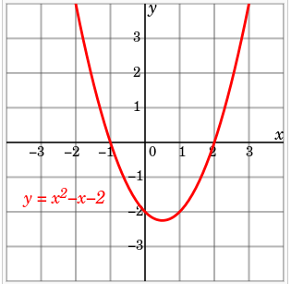

From the graph above state:
- The x-intercept
- The y-intercept
- The vertex
- The equation of the axis of symmetry
- The maximum value of the function.
- The coordinates of the maximum value
- The values for x for which x² - x -2 = 0
- The value of f(x) when x = 1
- The values of x when f(x) = 0
- The interval within which x lies when f(x)>0. Write your answer in the form a< x < b

