Oberlin High School
Subject: Geography
Grade: 8
Date: May 10, 2021
Lesson Topic: Latitude and Longitude

Summary of Content:
Lines of latitude are imaginary lines that run from east and west of the Equator. While lines of Longitude are imaginary line that runs north and south of the Prime Meridian. They are imaginary lines and are measured in degrees. These lines are used to locate places; however longitude is used to derive time and latitude used for distance. These lines are important as they help persons locate places, determine the time and help to prevent chaos as in the case of the Bering Strait.
Lines of Latitude
- The Artic circle (66¹/₂⁰ N)
- The tropic of cancer 23¹/₂⁰ N
- The equator 0⁰
- The tropic of Capricorn 23¹/₂ 0 S
- The Antarctic circle 66¹/₂ ⁰ S
- The north pole is at 90⁰ N
- The south pole is 90⁰S
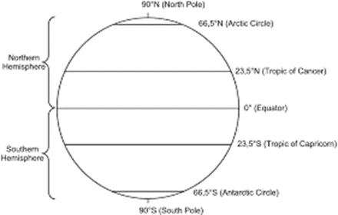
Characteristics of latitudes:
- All latitudes are parallel to each other. All parallel lines from the equator to the poles on the globe are called Parallels of Latitudes.
- They are measured in degrees from the center of the earth to the north and south of the equator.
- Latitudes make full circles around the globe whose circumferences reduce as one moves away from the equator to the poles. The equator is the great circle.
NB.
The N and S poles are located at 90⁰

- Run from east to west
- Determines position of a place.
- Every point on a parallel of latitude has the same value of latitude.
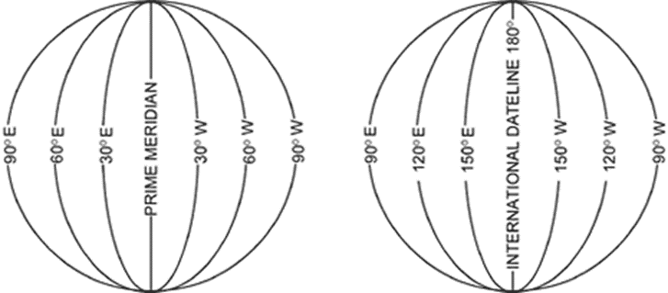
Lines of longitude:
- Run from north to south
- Each line forms a semi-circle and together forms a circle.
- Each line is a Great Circle
- They are not parallel
Locating places using latitudes and longitudes.

When locating points on the globe always start with the latitude reading then the longitude reading.
For example: 0⁰, 40⁰ E is a point in Kenya along the equator while 15⁰ N, 0⁰ is a point in Ghana.

Name: _______________________________
Date: ________________________________
Class: ______________
- Use the map below to state the coordinates of the following places in your notebook.
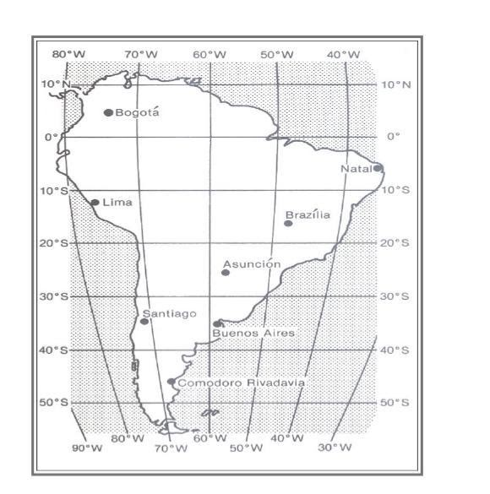
- Buenos Aires, Argentina 35°S, 59°W

(As you can see the latitude value was given first 35°, then the Longitude was done next which is 59°.) Go ahead and try these below.

- Santiago, Chile _____________________
- Lima, Peru ________________________
- Asunción, Paraguay _______________
- Bogotá, Colombia __________________
- Brasilia, Brazil _______________________ 5 marks

2. Write the names of the cities located at the following coordinates.
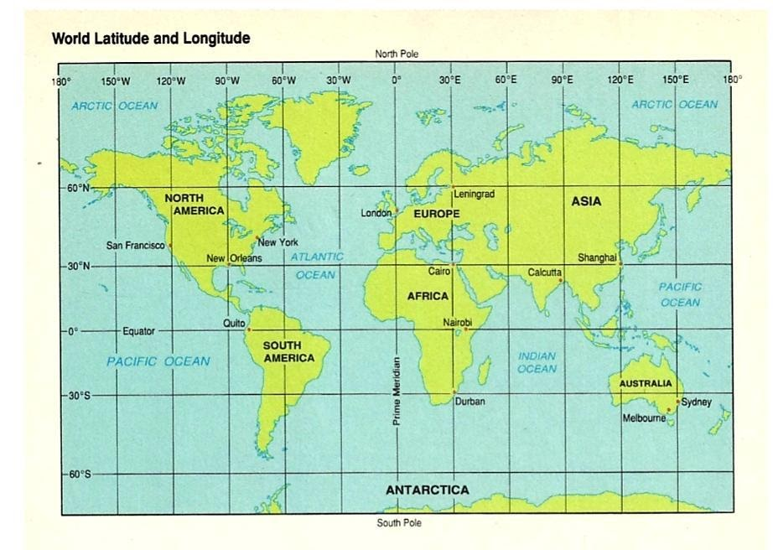
- Quito 0°, 78°W

Again, the latitude is done first. Which in this case it would be the equator 0º. And then 78° would be the Longitude. Now let’s try these below.

- 30°N, 90° ________________________
- 51°N, 0° __________________________
- 60°N, 30°E _____________________
- 30°N, 120 °E_____________________
- 30°S, 30°E_______________________
- 33° S, 151°E________________________
- 0°, 36 °E __________________________
- 41°N, 74°W _______________________ 8 marks
TOTAL MARKS-13

