Oberlin High School
Business Education Department
Information Technology
Grade 8
Topic: Researching Skills
Date: May 18- 28, 2021

The objectives of this lesson are:
- Define the internet
- How the internet works
- Define webpage and website
- Define search engine
- Identify the steps in using a search engine

The Internet
The internet also called the net is a network of networks which connects computers worldwide via a huge set of telecommunications links.

Who owns the internet?
No one owns or run the internet. The internet consists of independently maintained and administered networks. Each network on the internet is responsible for formulating its own policies, procedures and rules.

How the internet works?
To connect to the internet, you need a personal computer, a modem, a communication link such as telephone line or satellite dish and access to an internet service provider (ISP).
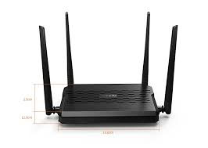A modem allows data to be transmitted over a telephone line. This data will be received by another computer at the end of the line. The data transmitted and received can be video, picture or voice or text.

An Internet Service Provider (ISP) is a company that has direct high capacity connection to one of the internet’s main networks. Since all of these networks are connected the internet service provider therefore provide users with access to the whole internet. Example of internet service providers are Flow and Digicel.

What is a web site and webpage?
A web site is a collection of web pages which are grouped together and is usually connected together in various ways.

A web page is a document which can be displayed in a web browser. In other words, a web page is what you see on the screen when you type in a web address, click on a link, or put a search in a search engine like google.

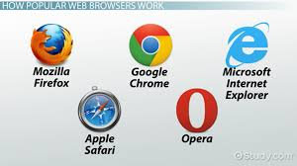 A web browser is a program that allows you to find, retrieve, view and send hypertext and hypermedia documents over the web. Popular browsers are Microsoft Internet Explorer, Morilla Firefox, Opera and Google Chrome.

Hypertext documents is a document that contains a hyperlink to another document. By clicking on a link in a hypertext document, a user can quickly jump to different content.
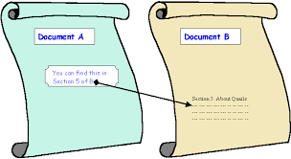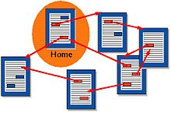

Hypermedia documents is a document that enable a user to gain or provide access to texts, audio and video recordings, photographs and computer graphics related to a particular topic.
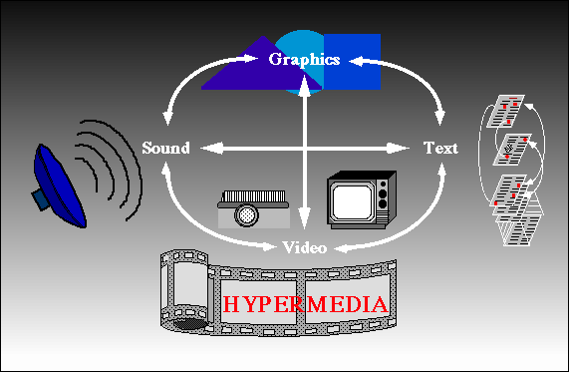

What is a web address?
A web address also known as a URL (uniform resource locator), is an Internet or intranet name that points to a location where a file, directory or website page is hosted. A URL has four parts: Protocol://Server/Path/Filename

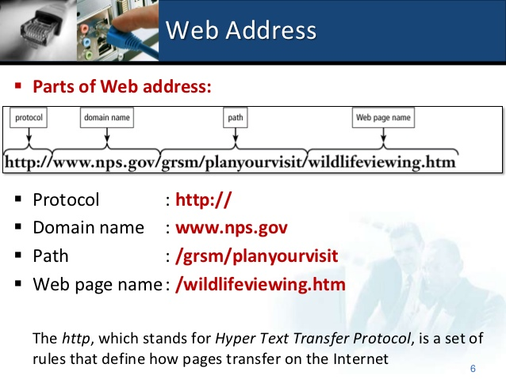

What is a search engine?
A search engine is a website that allows user to find information easily. A search engine is also called a web portal.
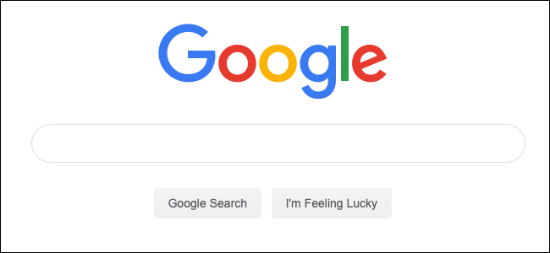

How to use a search engine?
- Open a web browser of your choice. Eg Google Chrome
- Navigate to a search engine in the web browser
- Type one or more keywords then press Enter on your keyboard. In this example, we'll search for recipes.

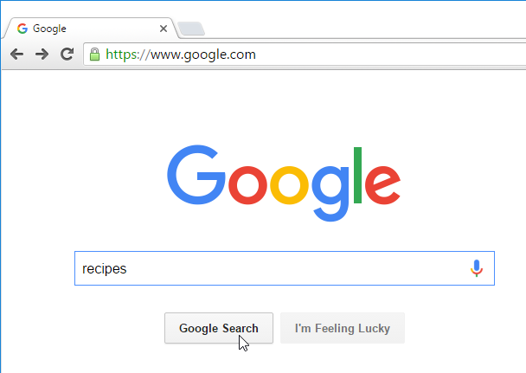

- After you run a search, you'll see a list of relevant websites that match your search terms. These are commonly known as search results
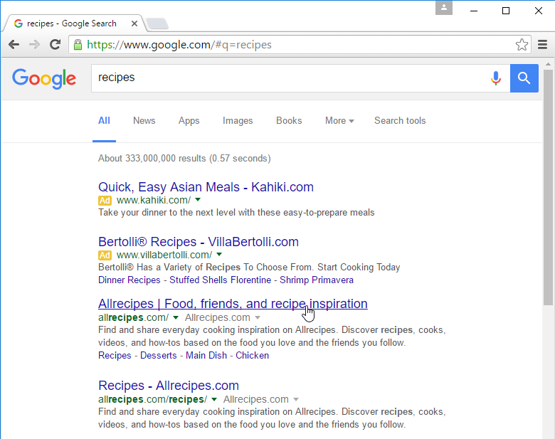

- You can click on any of the links provided to see if the information presented is what you are looking for.

